Game Theory for Rebels
A Guide for the Oppressed

Part I

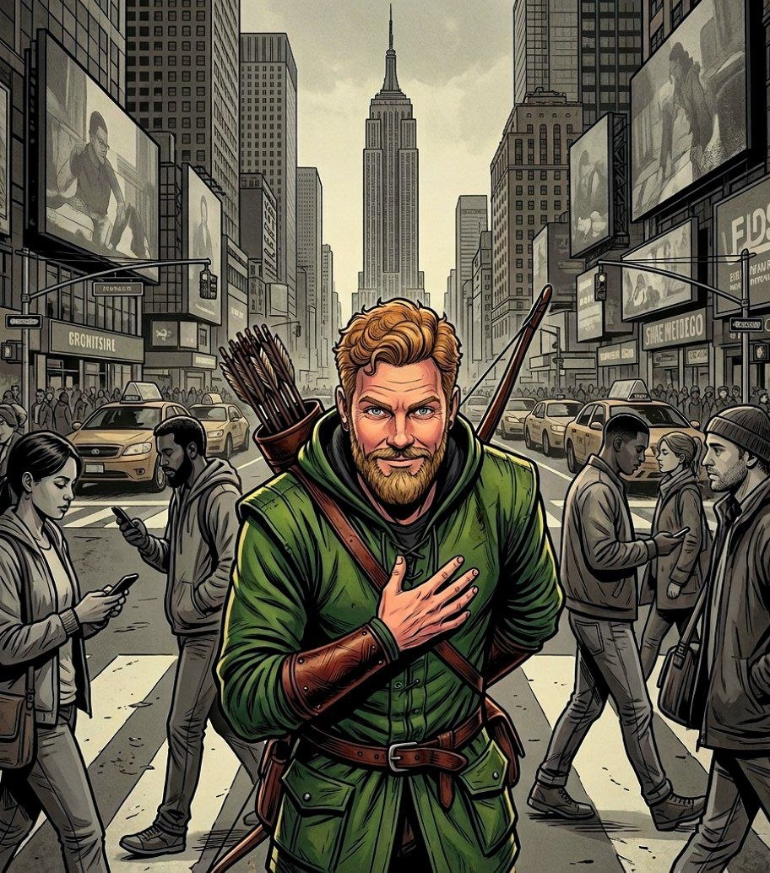

Ropes Pierre

Game Theory for Rebels
A Guide for the Oppressed

Part I

By Ropes Pierre

Published by:
The Swarm of Strategic Rebels
who Volunteer to share this document.
Copyright Notice (CC BY 4.0)

This work is released into the public domain under the Creative Commons Attribution Licence (CC BY 4.0). You are free to copy, distribute, and adapt this work, on condition that any derivative works or reproductions must properly name and credit the original source/author.

Since the author is anonymous, appropriate credit specifies where the author posts his philosophical work, more specifically https://thepragmaticrealist.substack.com/, and can be in several forms such as:

- "The Pragmatic Realist (Substack)", with or without hyperlink.
- "thepragmaticrealist.substack.com", with or without hyperlink.
- "Ropes Pierre", with hyperlink to Substack or the address displayed.
- "Ropes Pierre via The Pragmatic Realist (Substack)", with or without hyperlink.

Dedication

This project is meant to give hope to the hopeless. Oppression does not lead to a stable society, and while "might makes right" has been at the core of the world view of leaders for centuries, we prove herein that it does not lead to prosperity.

The manner in which this manuscript is intended to be shared is inspired by the printed pamphlets of Robespierre, a prominent figure in the French Revolution who tragically went mad trying to enact what I can only assume was a Masonic vision.

Robespierre initially gained popularity by insisting that the peasants must have access to justice if crimes are committed by the elites, and therefore I dedicate this work to him.

While we can learn from history, it is also possible to use Game Theory to avoid learning through trial by error. You are about to discover that Game Theory does present a way to structure society that ensures prosperity, but it requires us to change the way we look at leaders and power dynamics.

You do not need to burn down the system in order to fix it. You will soon see for yourself that there is a simple patch: Tit-for-Tat cost imposition. This results in an antagonistic balance where leaders are less tempted to Defect to Subverter interests, maximising the prosperity of the nation, or otherwise drastically escalating the odds of a tyranny falling.

However, Robespierre was right that the house needs to be cleaned. Allowing the old guard to train the new guard will certainly guarantee that the corruption remains intact. I therefore declare myself Ropes Pierre, because I am not calling for Guillotines!

Game Theory for Rebels 1: Introduction

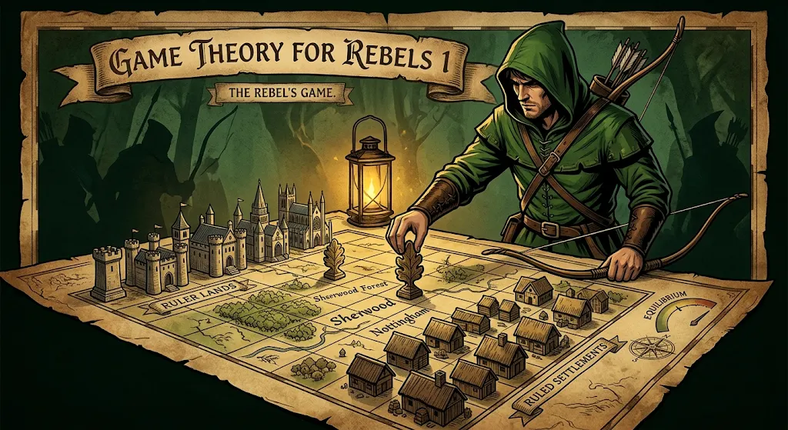
In modern politics, we have been conditioned to view societal conflicts through moral, legal, or ideological lenses. However, the dynamics of having a Ruler population and a Ruled population, and the conflicts between the two, follows established principles in the field of Game Theory.
The Ruler population has a long history of using Game Theory, and less rigorous predecessors like the strategic advice of Machiavelli, against the Ruled population to extract resources from the Ruled and to suppress their rights.
We are told to vote, to protest peacefully, or to appeal to the shared values of our institutions and everything will magically work itself out. To a pragmatic realist, this is shamefully naive because it ignores the underlying mechanics of power struggles and creates a situation where the Ruled loses every conflict, incentivising the Ruled to become even more aggressive in its value extraction.
The Ruler population already understands this. They have designed the playing field to make absolute compliance your path of least resistance.
Whether consciously or through trial and error, ruling elites use principles of Game Theory such as Asymmetric Information, cost-imposition strategies, and Mechanism Design to structure society in a way that optimises their own utility at your expense.
The aim of this series is not to encourage political unrest, it is to educate Rebels living under oppressive regimes about the aspects of Game Theory that they need to understand in order to maximise the value that both the Ruler and the Ruled populations get out of society.
The best way to fight back is to learn how the game works, and then to play the optimum strategy. There is no need to tear everything down, this is a guide on how to level up your game.

The Anatomy of the Game
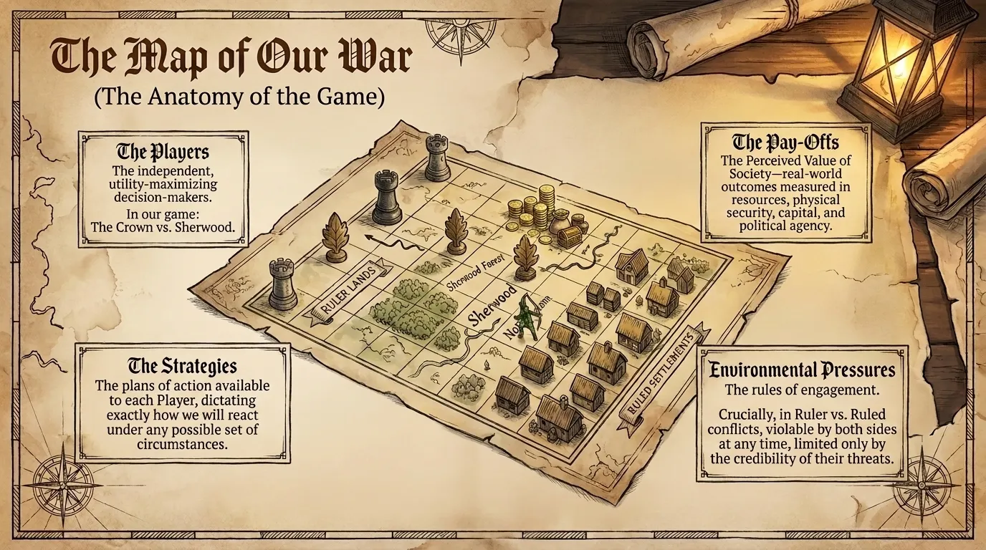
Every game or strategic conflict on Earth is governed by the four foundational Components of the Game:

The Players:
The independent, utility-maximising decision-makers involved in a game. Game Theory for Rebels defines the Player as the Ruler and the Ruled populations.

The Strategies:
The plans of action available to each Player, dictating exactly how they will react under any possible set of circumstances.

The Pay-Offs:
The real-world outcomes of the game, measured in the gain or loss of resources, physical security, capital, operational efficiency, or political agency.
We will group all the possible Pay-Offs between the Ruler and Ruled as the Perceived Value of society, which increases if there is mutually beneficial cooperation and decreases if either side imposes costs on the other.

The Environmental Pressures:
The rules imposed on the board that strictly limit the types of Strategies each Player can realistically deploy. These rules can be violable or inviolable depending on the game.
The some of Ruler vs Ruled Environmental Pressures are violable on both sides, which means that both sides are capable of changing the rules of engagement at any time, limited only by the credibility of their threats.

The Instability of Non-Equilibrium
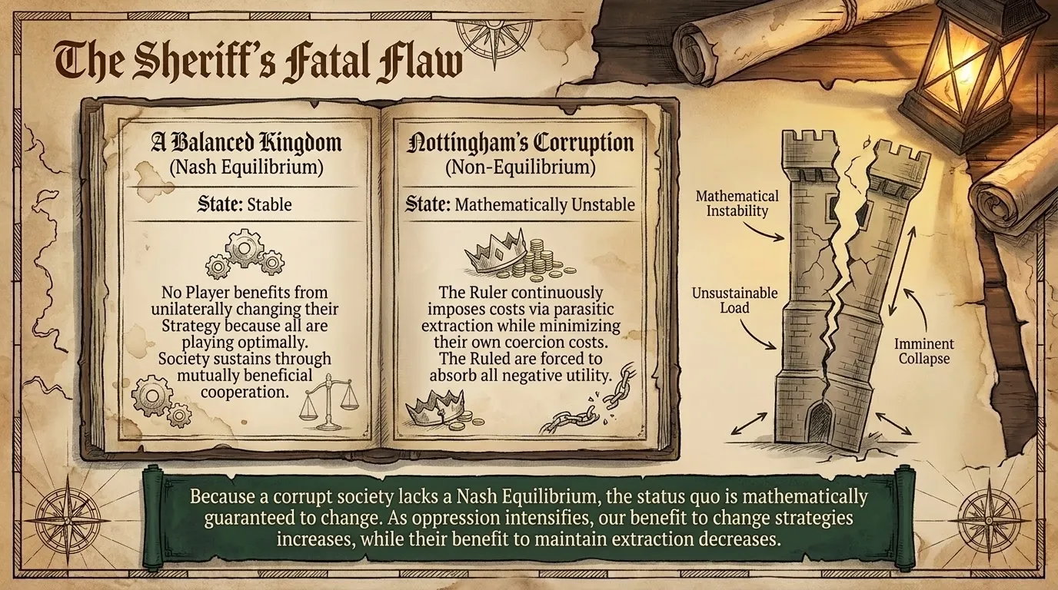
The central concept of modern Game Theory is the Nash Equilibrium: a situation where no Player can benefit from unilaterally changing their Strategy because all Players are playing the optimal strategy for the situation.
A corrupted society is fundamentally unstable because it is not in a Nash Equilibrium.
In a corrupt state, the Ruler continuously imposes costs on the Ruled through parasitic extraction while minimising their own costs of coercion. Because the Ruled are forced to absorb negative utility, the status quo is mathematically guaranteed to change.
As oppression intensifies, the benefit for the Ruled to change strategies increases while the benefit for the Rulers to keep their strategy of extraction decreases.

You are the Hope

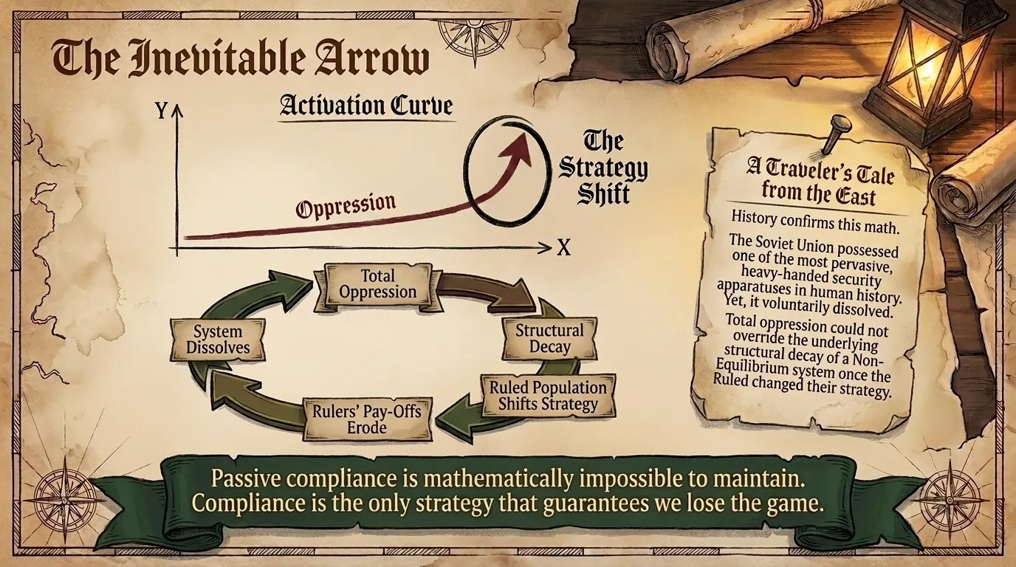
Game Theory gives an absolute mathematical assurance to those living under dystopian conditions that the status quo cannot remain permanent.
Because the system is in a Non-Equilibrium state, the Strategy of the exploited Ruled population is guaranteed to change. The Ruled cannot maintain passive compliance, it is mathematically impossible to remain in a Non-Equilibrium state for too long.
History confirms this mathematical inevitability.
The Soviet Union possessed one of the most pervasive, heavy-handed security apparatuses in human history. Yet, total oppression could not override the underlying structural decay of a Non-Equilibrium system.
In the end, the Soviet Union decided to voluntary and peacefully dissolve. The Pay-Offs for the Rulers were eroded by the changing strategies of the Ruled.
The solution was always in the hands of the Ruled, compliance is the only strategy that guarantees that you lose the game.

